ExpenseMate – Refactoring Report

By: 24k-3099 & 24k-3041

Part B: Architectural Refactoring to Layered Pattern
Architecture Overview
ExpenseMate was refactored from a monolithic controller setup into a strict layered architecture to enforce separation of concerns, decouple persistence from HTTP routing, centralise business validation, and make every core module testable through dependency injection.
- Before: controllers handled HTTP endpoints, input validation, budget calculations and direct DbContext (LINQ) queries, so the UI called controllers that talked straight to the database.
- After: Controller → Service → Repository → Database. Controllers only bind requests and return HTTP results, services hold business rules, and repositories own all EF Core access.
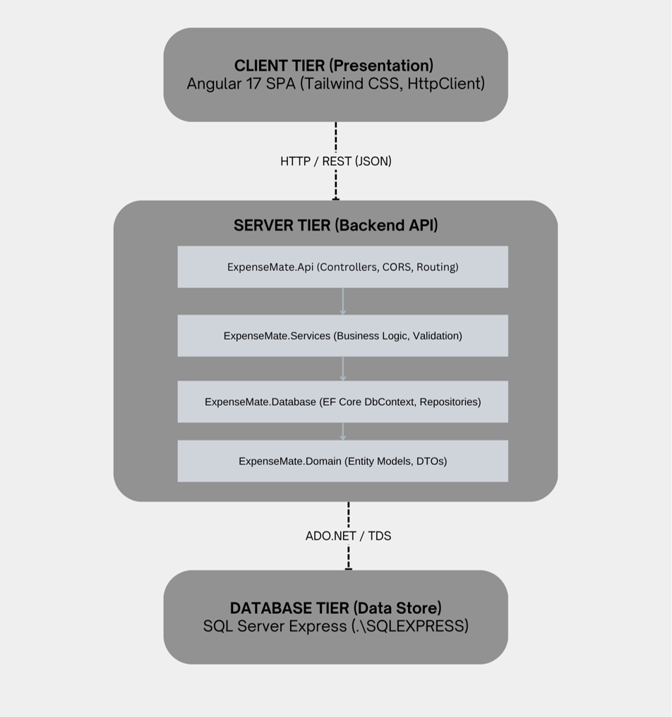
Figure 1: ExpenseMate architecture after refactoring

Layer mapping: Controllers = ExpenseMate.Api; business logic and validation = ExpenseMate.Services; DbContext and repositories = ExpenseMate.Database; entities and DTOs = ExpenseMate.Domain.
Features Refactored
Feature 1: Add & Manage Expenses (ExpenseController → ExpenseService → ExpenseRepo)
Layer | Refactored Responsibility
Controller | Receives expense payloads via HTTP POST/GET/DELETE, checks the payload exists, delegates to IExpenseService and returns Ok, BadRequest or NotFound.
Service | Enforces the Amount > 0 guard, assigns timestamps and orchestrates calls to IExpenseRepo.
Repository | Encapsulates EF Core operations (AddAsync, ToListAsync, Remove) with no business logic.
Database | SQL Server Expenses table.

Feature 2: Set Monthly Budget & Budget Alert Status (BudgetController → BudgetService / BudgetAlertService → BudgetRepo)
Layer | Refactored Responsibility
Controller | Handles GET /api/Budget/{month} and POST /api/Budget, validates DTO integrity and maps service errors to HTTP 400.
Service | Verifies BudgetAmount > 0, enforces 1% ≤ AlertThreshold ≤ 100%, computes usage against total expenses and evaluates isAlertTriggered.
Repository | Persists data through ExpenseMateDbContext (GetBudgetByMonthAsync, SaveBudgetAsync).
Database | SQL Server Budgets table.

Code-Quality Improvements
- Separation of concerns: controllers were bloated with DbContext queries and alert logic; they are now thin HTTP entry points, with logic in services and queries in repositories.
- Testability: controllers depend on IExpenseService and IBudgetService, and services on IExpenseRepo and IBudgetRepo, so dependencies can be mocked (Moq/NSubstitute) instead of needing a real or in-memory database.
- Centralised validation: negative-amount and range checks were inconsistent across endpoints; they now live once in ExpenseService and BudgetService, so every caller passes the same rules.
- Data access safety: database logic is isolated in IncomeRepo, ExpenseRepo and BudgetRepo, so controllers no longer see DbContext state or expose raw entities.

Verification & Regression Testing
- Dependency injection: IIncomeRepo, IExpenseRepo, IBudgetRepo, IIncomeService, IExpenseService, IBudgetService and IBudgetAlertService are registered as scoped services in Program.cs.
- Regression: the NUnit Playwright suite (ExpenseMate.Tests) passed for income recording, expense entry, budget alert calculation and negative-value validation, confirming no change in feature behaviour. [Insert test summary screenshot]

